**Advance Excel Assignment 2**

1. What does the dollar($) sign do?

It is absolute reference of a cell in excel. $ dollar sign fixes the reference given to the cell.

In below examples, we converted relative cell reference to absolute cell reference

First by fixing $E$1 & then by freezing E$1.

Relative

|  |  |  |  |
| --- | --- | --- | --- |
| **Numbers** | **Formula** | **Multiplication Value** | **20** |
| **1** | **=E1*B2** | **20** |  |
| **2** | **=E2*B3** | **0** |  |
| **3** | **=E3*B4** | **0** |  |
| **4** | **=E4*B5** | **0** |  |
| **5** | **=E5*B6** | **0** |  |
| Absolute  Freezing row & column both  **Numbers** | **Formula** | **Multiplication Value** | **20** |
| 1 | =$E$1*B2 | 20 |  |
| 2 | =$E$1*B3 | 40 |  |
| 3 | =$E$1*B4 | 60 |  |
| 4 | =$E$1*B5 | 80 |  |
| 5 | =$E$1*B6 | 100 |  |

Absolute Freezing row value & relative column value in order to drag down formula across rows.

|  |  |  |  |
| --- | --- | --- | --- |
| **Numbers** | **Formula** | **Multiplication Value** | **20** |
| 1 | =E$1*B2 | 20 |  |
| 2 | =E$1*B3 | 40 |  |
| 3 | =E$1*B4 | 60 |  |
| 4 | =E$1*B5 | 80 |  |
| 5 | =E$1*B6 | 100 |  |

2. How to Change the Reference from Relative to Absolute (or Mixed)?

Relative cell referencing- formula (E1*B2) gets dragged down to other rows & it takes the values in cells where the formula is copied w.r.t to values given in these cells.

In Below example, Row 1 for column E takes formula as E1*B2, but when this formula is copied to Row 2- then it starts taking formula as E2 * B3 w.r.t to values given in 2 row for these cells. This is called relative cell referencing, which is by default present in excel.

|  |  |  |  |
| --- | --- | --- | --- |
| **Numbers** | **Formula** | **Multiplication Value** | **20** |
| **1** | **=E1*B2** | **20** |  |
| **2** | **=E2*B3** | **0** |  |
| **3** | **=E3*B4** | **0** |  |
| **4** | **=E4*B5** | **0** |  |
| **5** | **=E5*B6** | **0** |  |
| Absolute  Absolute Cell reference- Freezing row & column both  **Numbers** | **Formula** | **Multiplication Value** | **20** |
| 1 | =$E$1*B2 | 20 |  |
| 2 | =$E$1*B3 | 40 |  |
| 3 | =$E$1*B4 | 60 |  |
| 4 | =$E$1*B5 | 80 |  |
| 5 | =$E$1*B6 | 100 |  |

Mixed cell referencing- Freezing row value in order to drag down formula across rows.

|  |  |  |  |
| --- | --- | --- | --- |
| **Numbers** | **Formula** | **Multiplication Value** | **20** |
| 1 | =E$1*B2 | 20 |  |
| 2 | =E$1*B3 | 40 |  |
| 3 | =E$1*B4 | 60 |  |
| 4 | =E$1*B5 | 80 |  |
| 5 | =E$1*B6 | 100 |  |

3. Explain the order of operations in excel?

Parentheses, Exponents, Multiplication, Division, Addition, Subtraction

4. What, according to you, are the top 5 functions in excel and write a basic syntax for any of two?

1. V look up, Pivot table, concatenate, conditional formatting (highlighting & removing duplicates), Filters application on large amount of data sets.
2. V look up-
3. In the parentheses, enter your lookup value, followed by a comma- What you want to look up
4. Enter your table array or lookup table, the range of data you want to search, and a comma: (H2,B3:F25,- where you want to look for it
5. Enter column index number- the column number in the range containing the value to return
6. Enter the range lookup value, either TRUE or FALSE- return an Approximate or Exact match – indicated as 1/TRUE, or 0/FALSE

In below example, we applied V-look up to get data in H column basis “numbers” column values by searching it in table a , b where data present in “a” & “numbers” columns is same, so formula returns the data present in “b” column when we give column value as 2 in our formula.

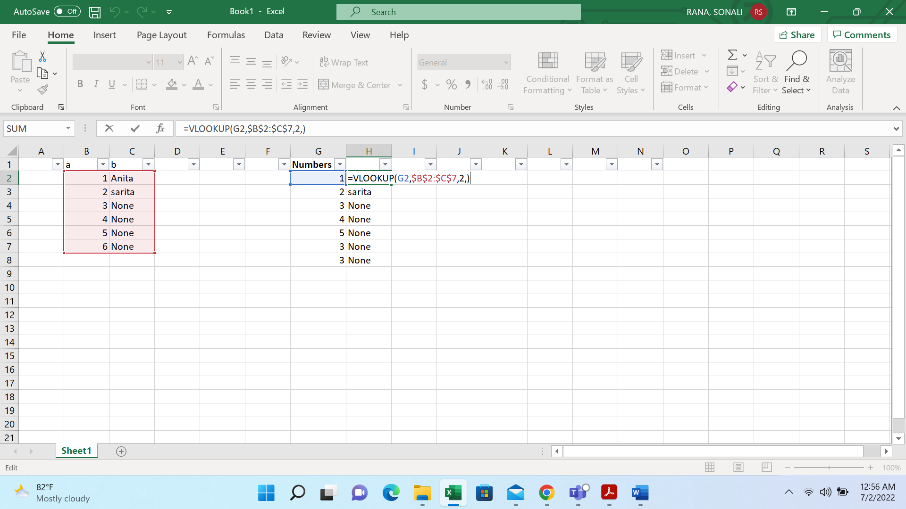

Pivot Table

1.Select the cells you want to create a PivotTable from.

2. Press – Alt+ nv- short cut key

3. This will create a PivotTable based on an existing table or range.

4. Choose where you want the PivotTable report to be placed

5. Click OK.

6. Arrange the values in rows & values headers as per requirement & analyze the data.

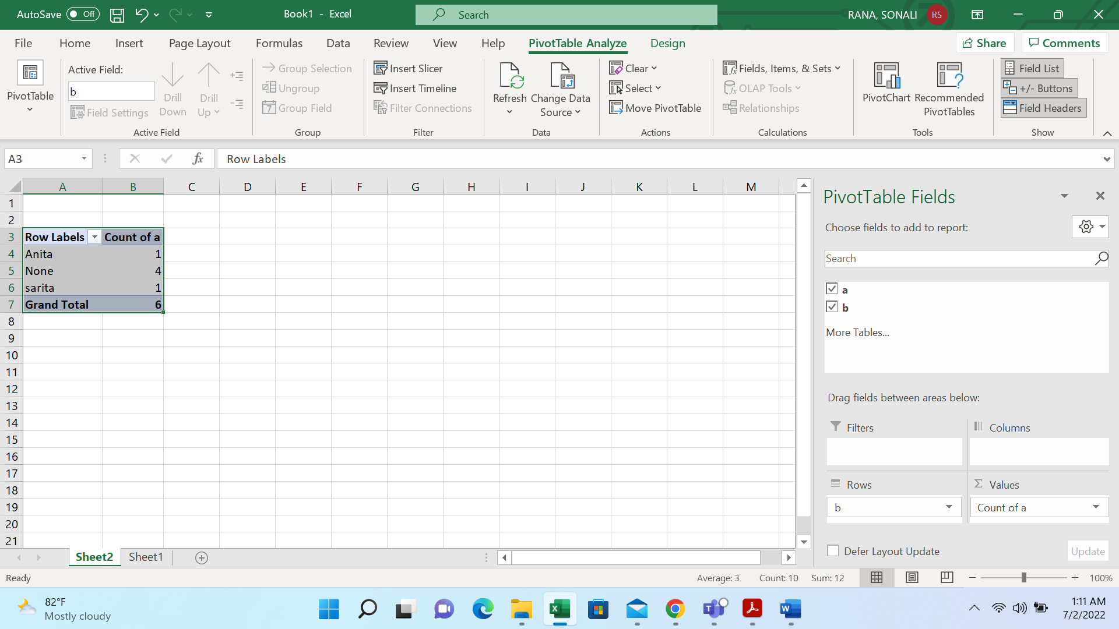

5. When would you use the subtotal function?

I would use subtotal function when I’m trying to sum up or taking out the average for filtered values only & don’t want sum or avg for entire data.

This is not possible with normal Sum or Avg formula as it takes sum or avg for entire data even if we are working on filtered data that’s when we use Subtotal formula.

6. What is the syntax of the vlookup function? Explain the terms in it?

1. V look up-
2. In the parentheses, enter your lookup value, followed by a comma- What you want to look up
3. Enter your table array or lookup table, the range of data you want to search, and a comma: (H2,B3:F25,- where you want to look for it
4. Enter column index number- the column number in the range containing the value to return
5. Enter the range lookup value, either TRUE or FALSE- return an Approximate or Exact match – indicated as 1/TRUE, or 0/FALSE

In below example, we applied V-look up to get data in H column basis “numbers” column values by searching it in table a , b where data present in “a” & “numbers” columns is same, so formula returns the data present in “b” column when we give column value as 2 in our formula.

